**APPLICATION PROGRAMMING**

**GROUP ONE**

**PROJECT DOCUMENTATION**

**MEMBERS**

BRITNEY RAEL 21/04863

PURITY NJENGA 21/05462

DUNCAN MUNENE 21/04706

MICHEL LUKOSE 21/07131

LANAGAT ENOCH 21/04976

COLLINS GIKUNGU 21/05449

VINCENT MUOKI 21/06379

GEORGE SANAET 21/07618

**JUBE SUPERMARKET MANAGEMENT SYSTEM**

**INTRODUCTION**

Jube supermarket management system is a simple system created under visual studio (VB.NET) programming tools. The system is designed to be interactive between the management, employee, customers and the product in the supermarket. The system has a simple GUI that every user can interact with. It is also connected to a Microsoft access database.

**SYSTEM OVERVIEW**

**EXPLANATION**

LOGIN(WINDOW)

CREATE PASSWORD

SALES WINDOW

PURCHASES WINDOW

REPORT WINDOW

EMPLOYEE

CASHIER

MANAGER

CUSTOMER

The system when compiled starts with a welcome window which is form one. The window allows the end user to choose the path to make i.e. cashier or manager or customer. The option is listed by Combo box.

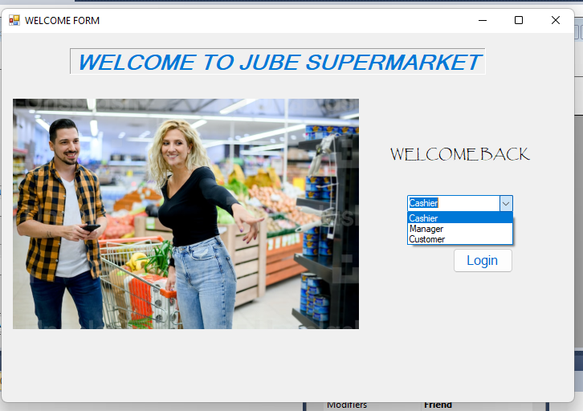

If the user is a cashier and chooses the cashier path, he/she clicks login button and leads to a login window. In this window the user enters password if he/she has an account already. He can view the password by clicking the checkbox show password, can clear password/username if entered wrong one by reset button or login using login button.

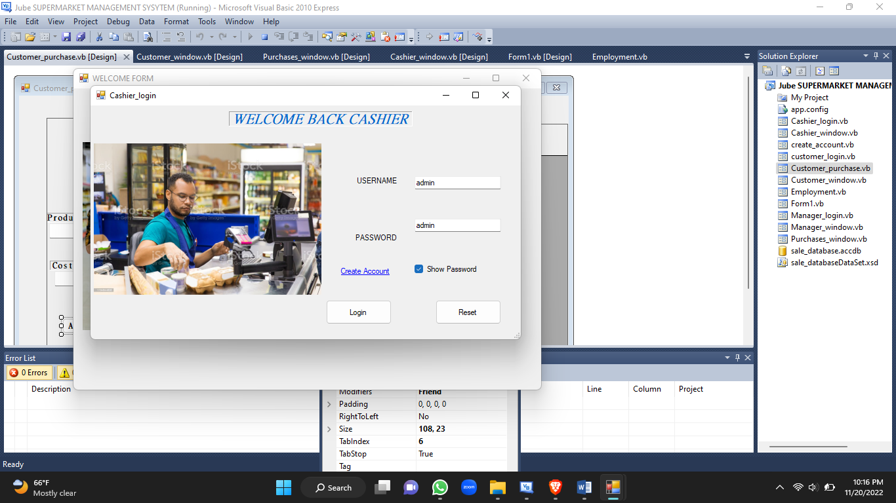

Furthermore he/she can create account by clicking create account link label. The link label opens create account window where he/she can have account created successfully.

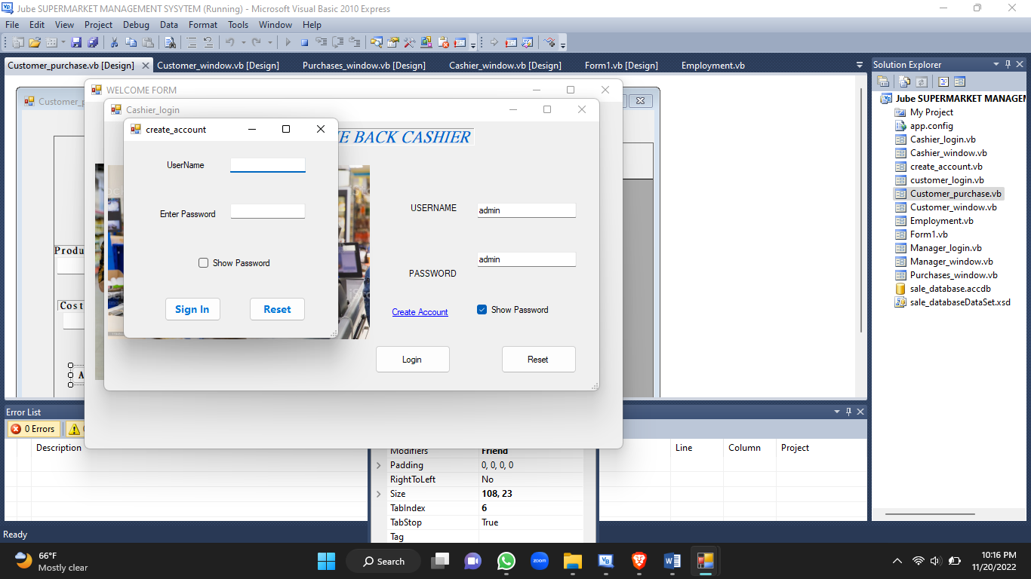

After login in as cashier, the cashier window opens where he/she can make updates on the sales database by adding information by entering details on the textboxes and clicking enter to add sale in the database. He can clear textboxes information by reset and also can display the sales in the Datagrindview panel by clicking show sales. 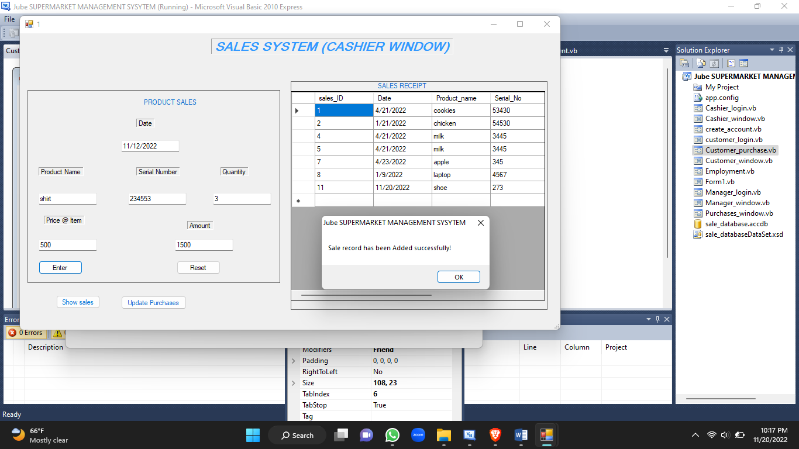

He/she can also update purchases by clicking the update purchase button which opens the purchase window. In the purchase window he/she enters the products bought descriptions and clicks the enter button to add a new record. He/she can clear all information by using reset button. Also, can show purchase in the DatagrindView panel by clicking show purchase button.

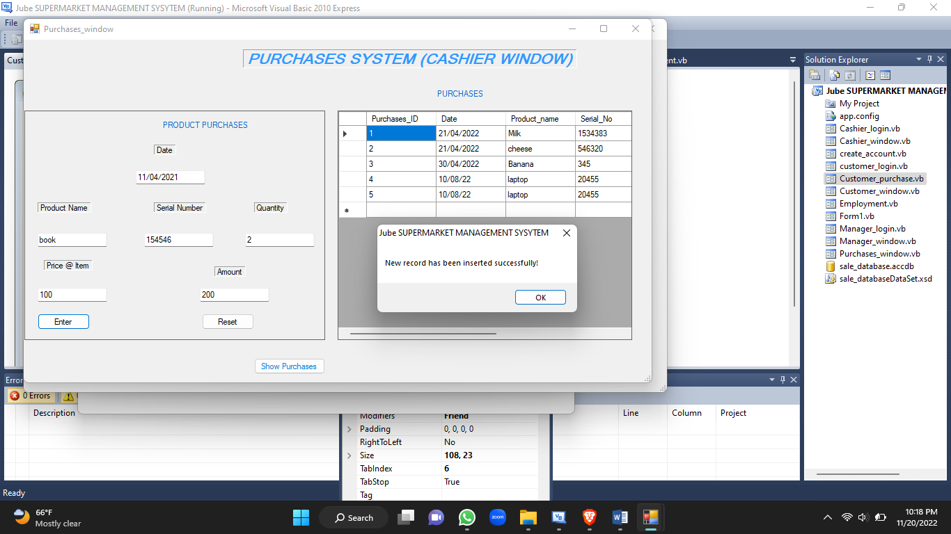

If the user is a manager, he/she choses the manager clicks login, goes to manager login. Just like cashier, he/she can maneuver through the login and create password the same way.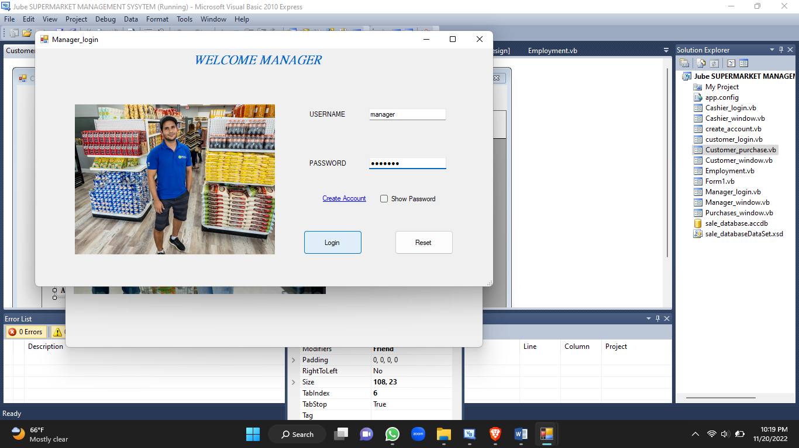

When login is successful he/she gets to the manager window which is basically the report. Using the DataGrid view panel and by clicking respective buttons the manager can have a report on the sales,

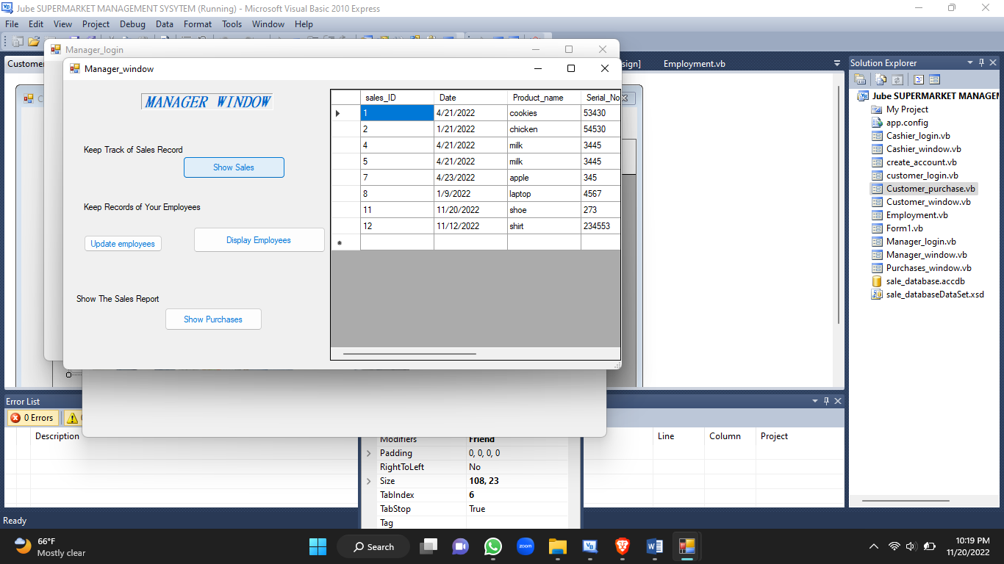

employees

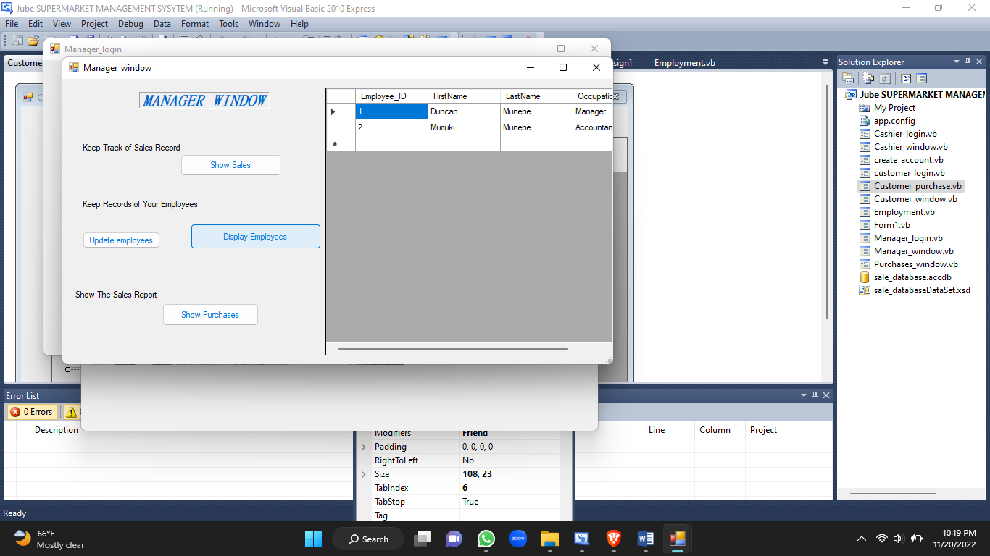

and purchases.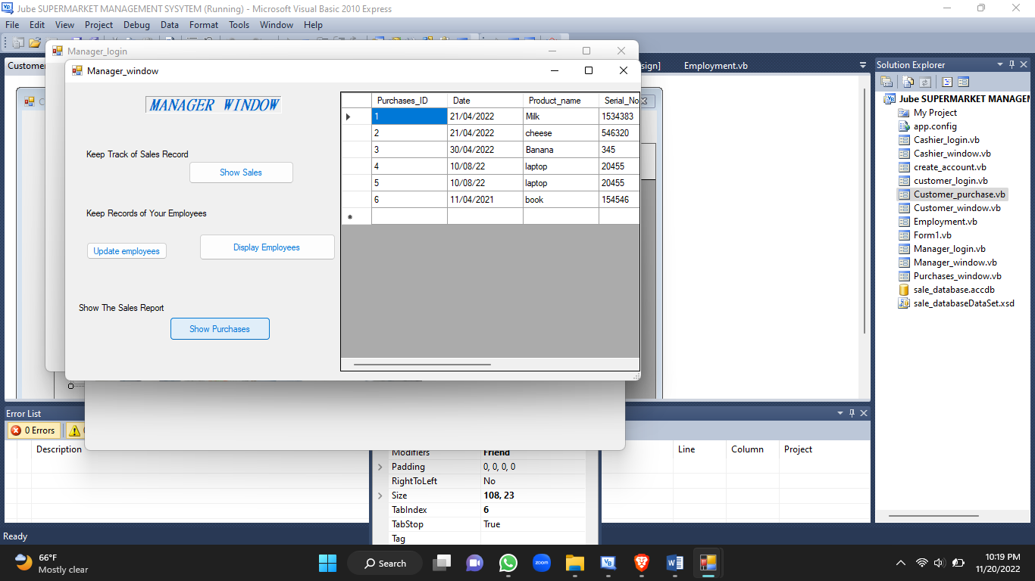

More so, he/she can update the employee details by clicking the update employee button and lead to employee window. He/she enters the employee details required and clicks enter to update the employee table.

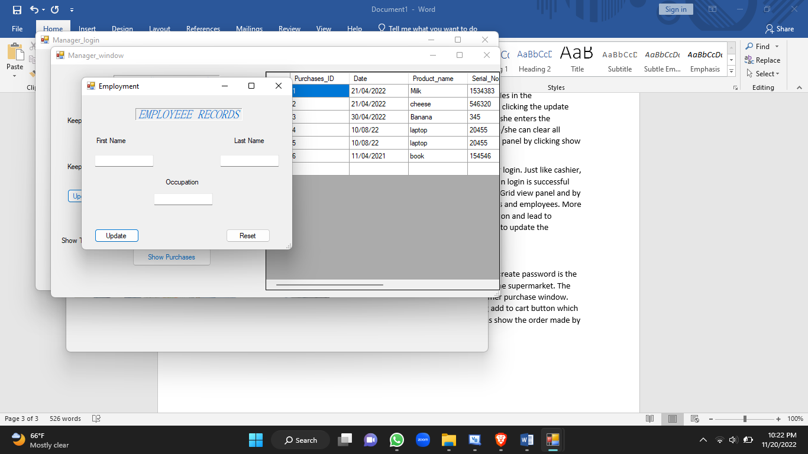

If the end user is customer and choses the customer path, the login process and create password is the same.

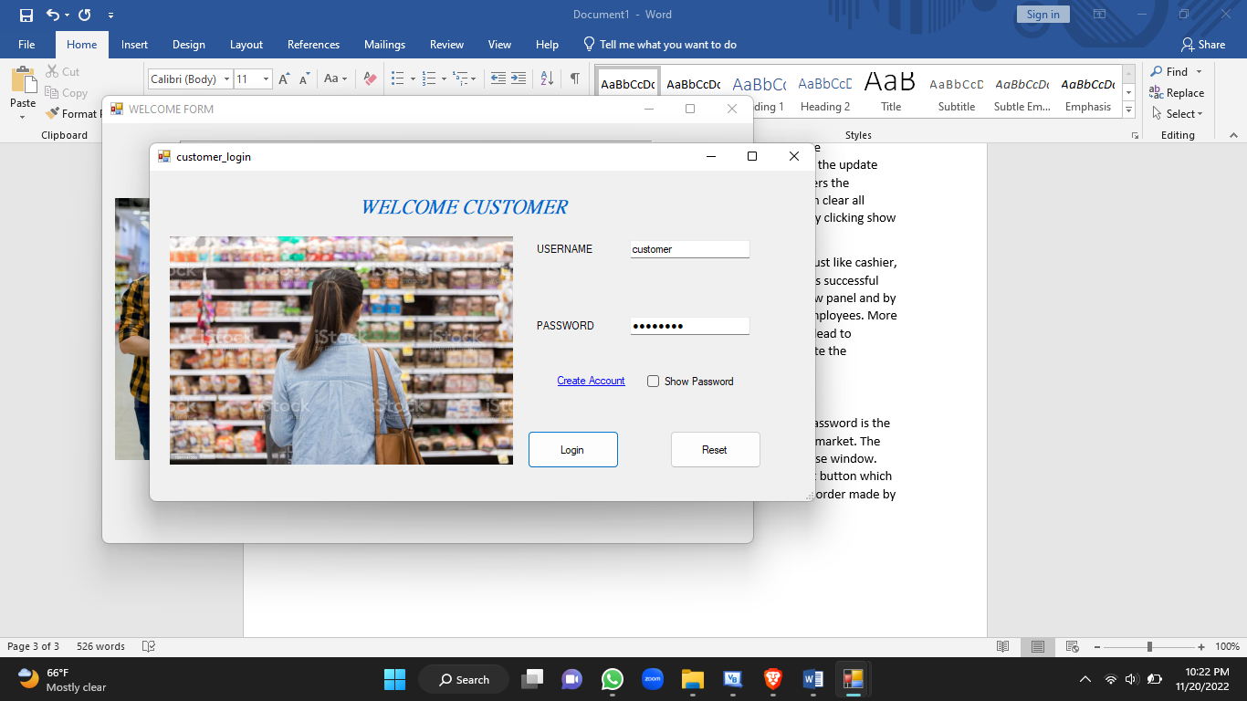

After login in the customer window opens and displays some of goods in the supermarket. The customer can buy the goods by clicking buy now buttons which leads to customer purchase window.

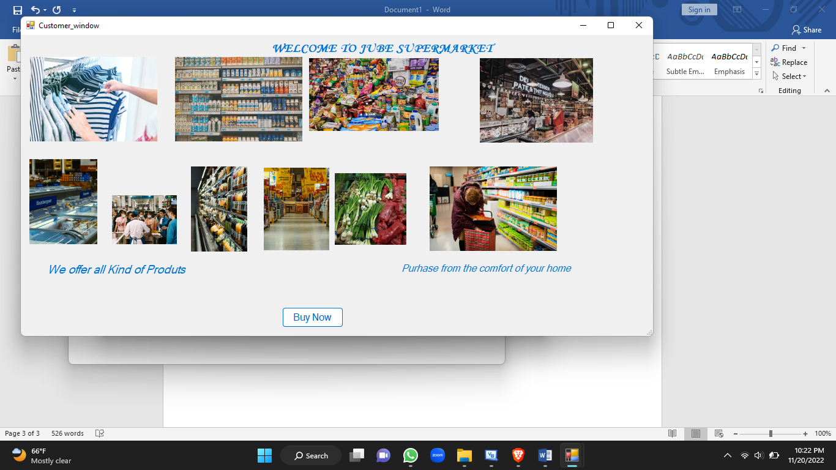

The customer adds the item to cart by filling the item information and clicking add to cart button which updates the purchases. He/she can clear item details by reset button as well as show the order made by show the order button which displays the items added.

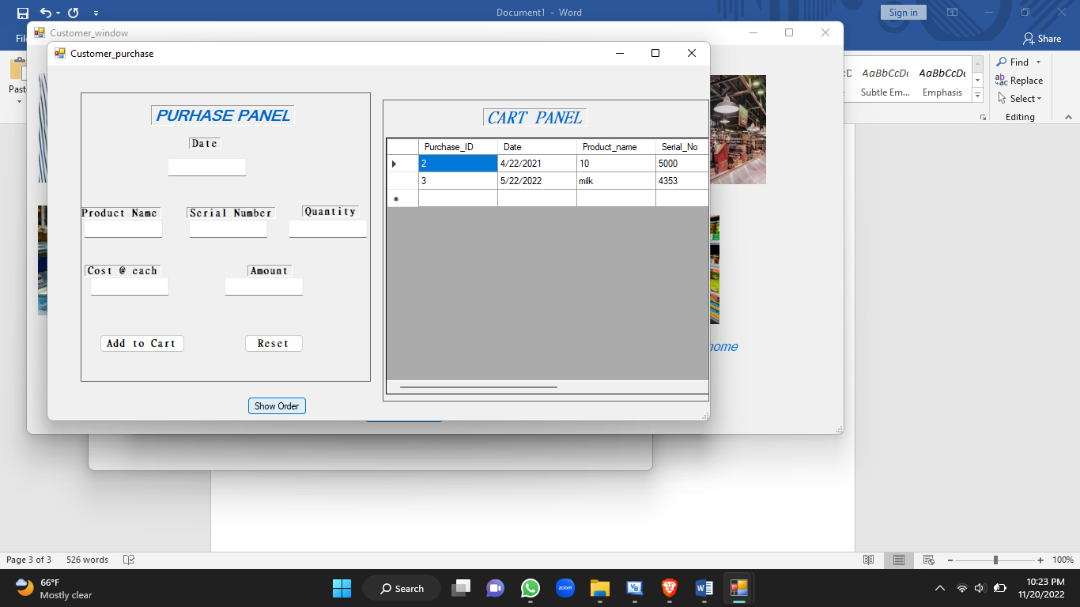

The system has incorporated various codes that allow the user to move from one form to another, source data from the Microsoft access database and display them, add information to the database through the visual basic form.

The coding that is on the login button allows the user to move to the next form. Example the login button on welcome form helps move to login form

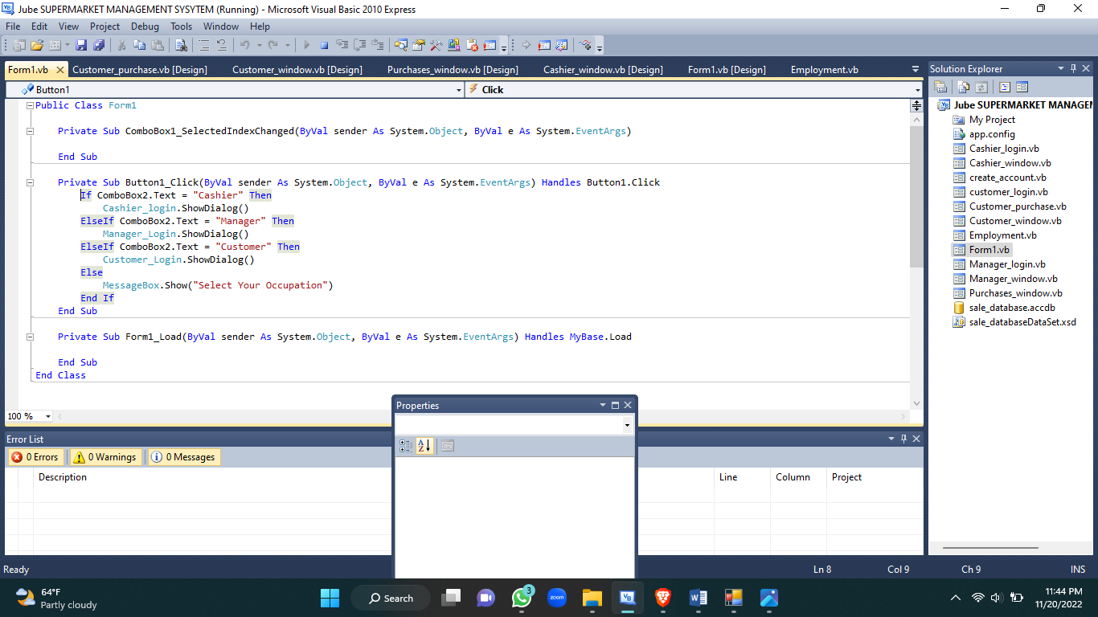

In the enter buttons on every form we have the codes that allow the details entered in the textbox to be recorded in the specified table in the Microsoft access database. Example the employee database is updated under the following code.

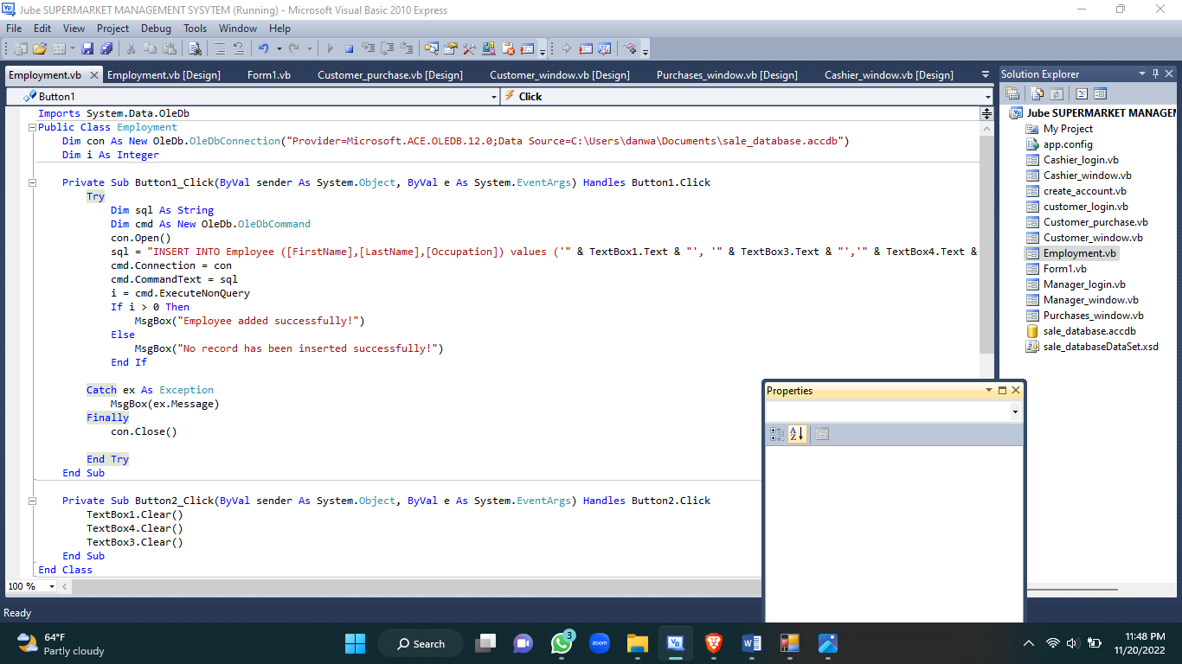

Even the show purchases, show employee, show sales buttons have codes behinds them that helps retrieving the information on the database and showing it at the datagrindview. Example is the show sales button.

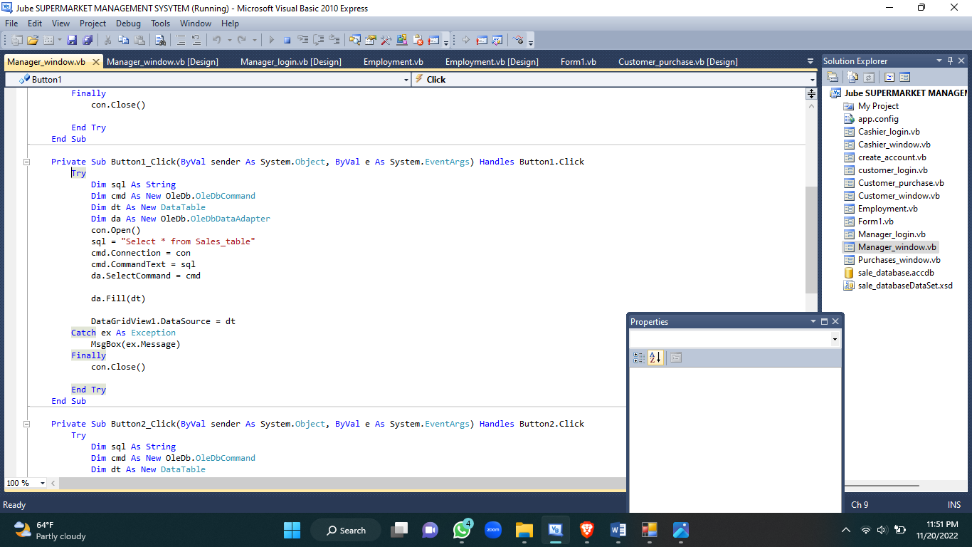

**CONCLUSION**

The Jube supermarket management system has been developed as a simple system that is easy and convenient to interact with. The system graphical user interface is friendly and the database is easily accessible, modifiable and maintainable.